Primitive Network

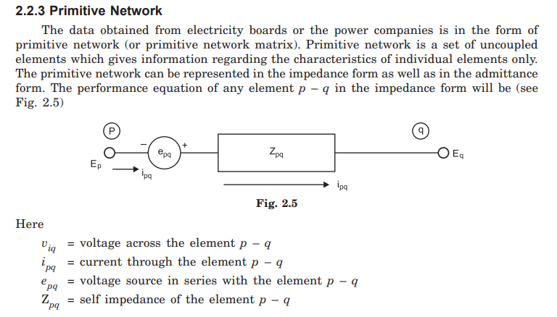

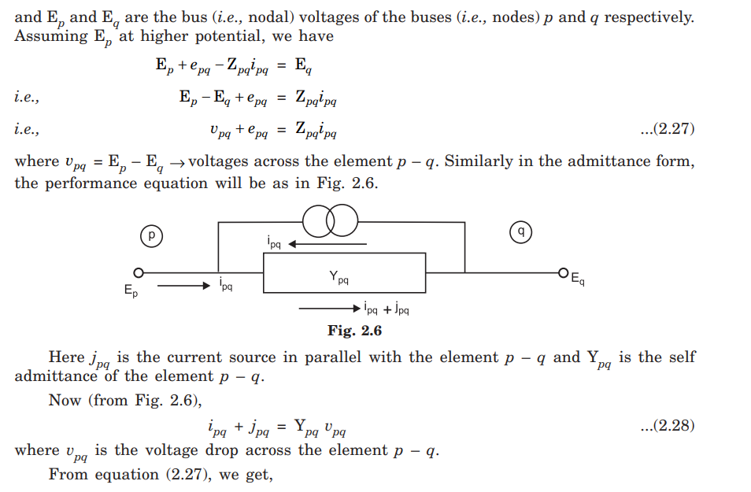

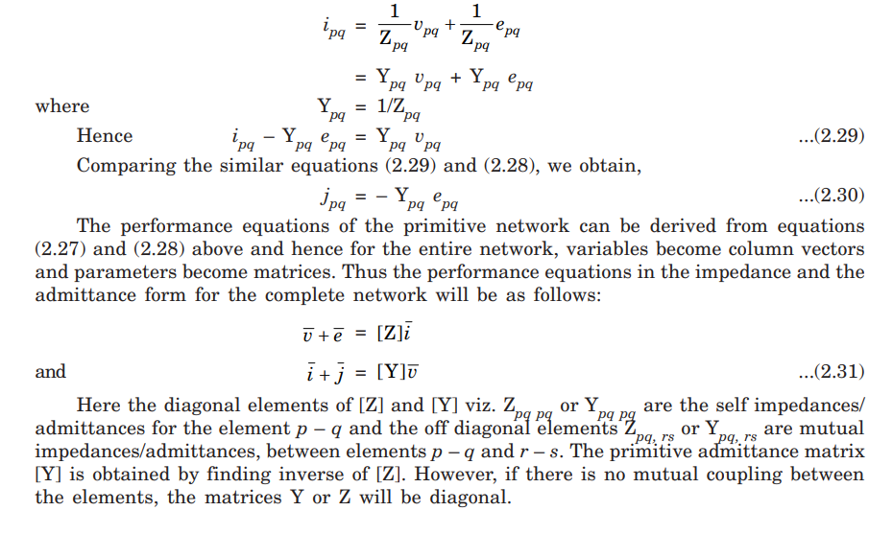

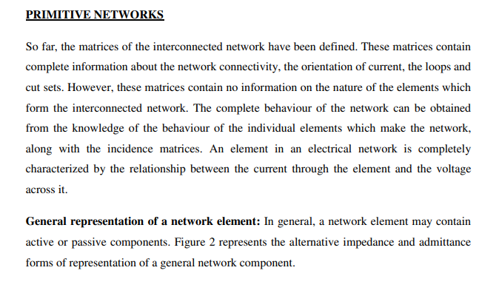

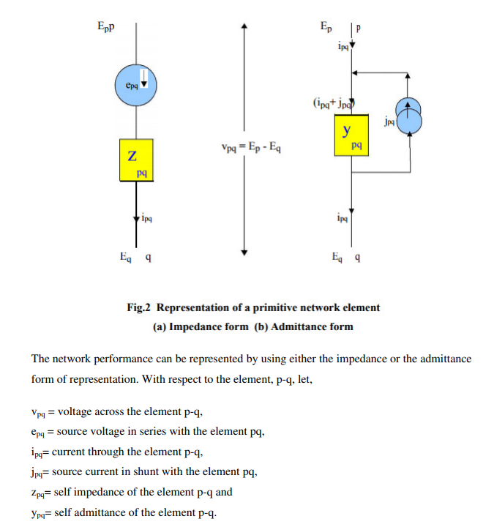

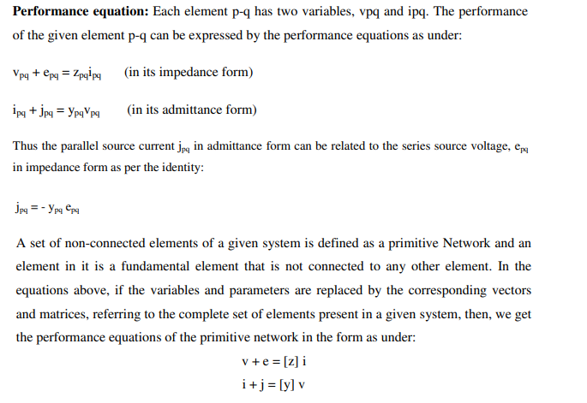

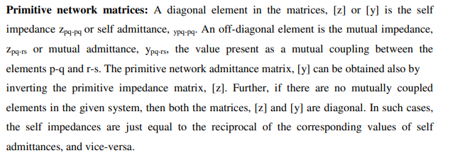

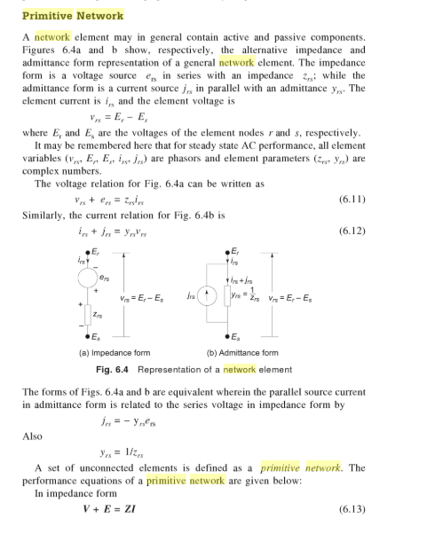

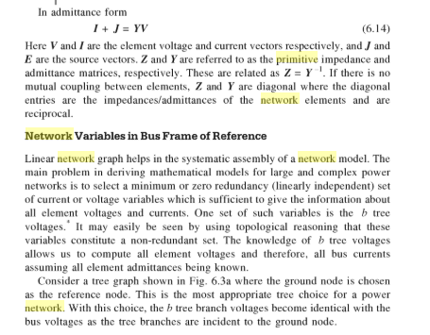

As we Electrical Engineering depends on

Ohms Law

KVL and

KCL

These are three our Basic rules of Electrical Engineering

So according to ohms law

V = IR

Or

V = IZ

Similarly V = 1/Y .I

I = Y.V

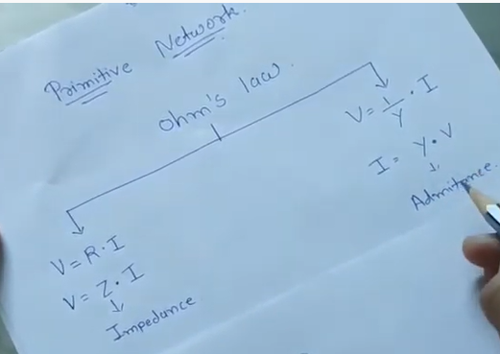

Primitive word comes from the prime and prime means main and main means original

So primitive network gives us a characteristics of each element of the network individually

So if we want to analyse the characteristics of whole network, so we have know the characteristics of each element.

Here we take one single line diagram of one Bus bar system in which one generating station , B1 and B2 is two buses and in B/W B1 and B2 is our transmission line and load is here

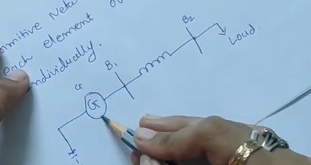

So to analyse a system so first we separate the Generator

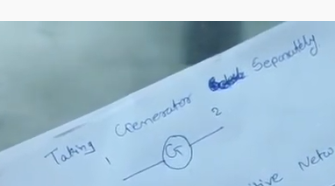

To know the characterize of the generator, so primitive network can be represented in two ways

1. Primitive Impedance network
2. Primitive Admittance network

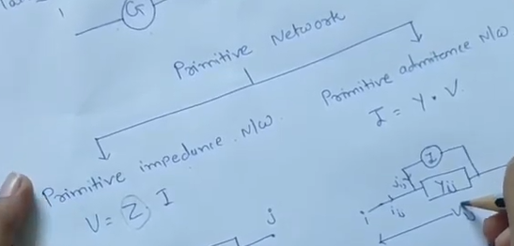

Here two nodes are called as I and j node, than impedance of ij is Zij and emf of that network is eij this is the way to represent the Primitive Impedance Network

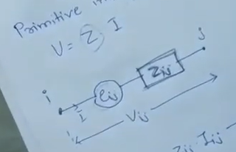

If we want primitive admittance network we use one current source and admittance Yij

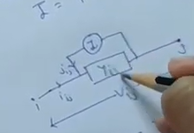

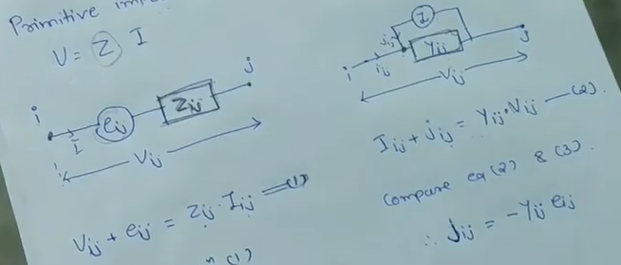

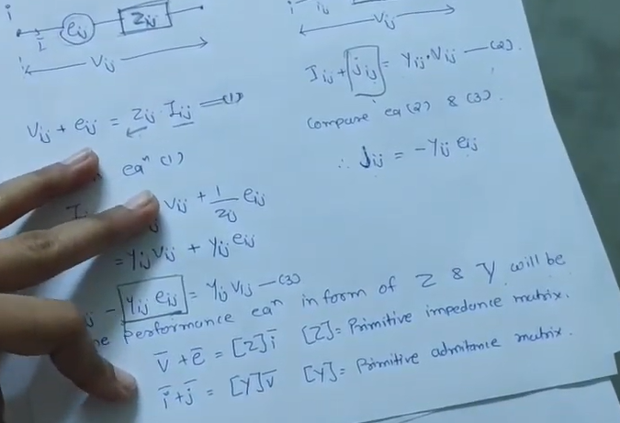

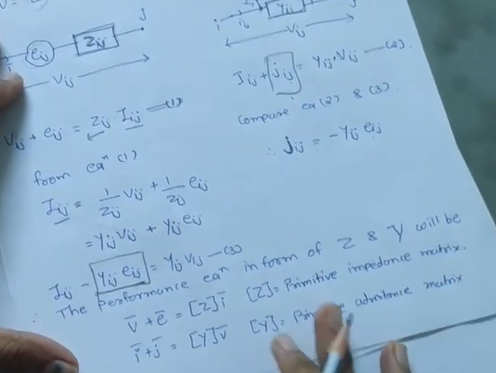

So the help of these two equations we can analyze any system